Name : Saurabh Sanjay Jadhav

Topic : Ansible Module.

Assignment no. : 12

1. File module :

Ansible all -I /etc/ansible/hosts -m file -a ‘name=/tmp/file1.txt state=touch’

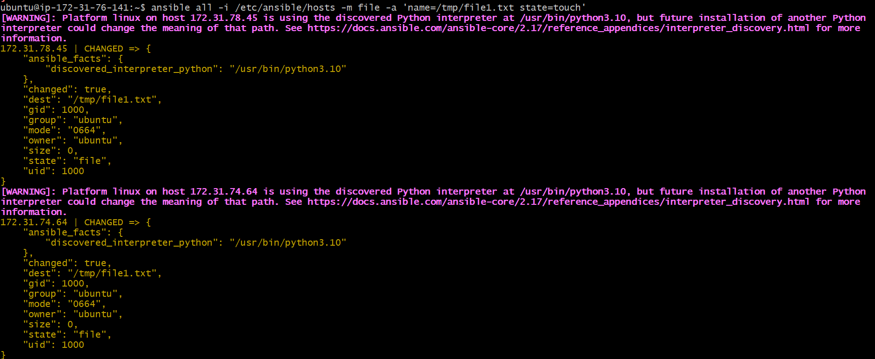

Ansible all -I /etc/ansible/hosts -m file -a ‘name=/tmp/Saurabh state=directory’

Worker-node-1:

Files created in nodes.

Ansible all -I /etc/ansible/hosts -m file -a ‘name=/tmp/file1.txt state=absent’ -b

1. Copy module :

Ansible all -I /etc/ansible/hosts -m copy -a ‘src=Saurabh.txt dest=/tmp’ -b

Work-node-1:

**Cannot copy multiple files at a time.**

1. Fetch module: Copy files from host machine local machine and keep in folder with ip address as name.

Ansible all -I /etc/ansible/hosts -m fetch -a ‘src=/etc/passwd dest=/tmp’ -b

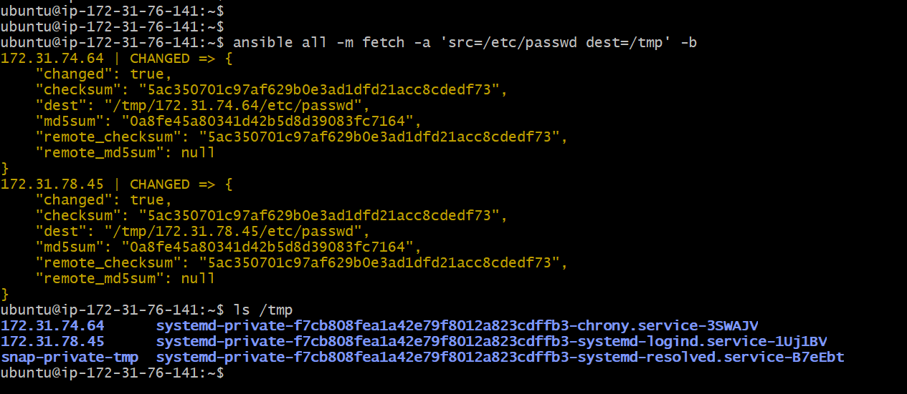

1. Service module:

Install nginx module :

Ansible all -m apt -a ‘name=nginx state=present’ -b

Start the nginx service

Stop the nginx service

Restart the nginx service

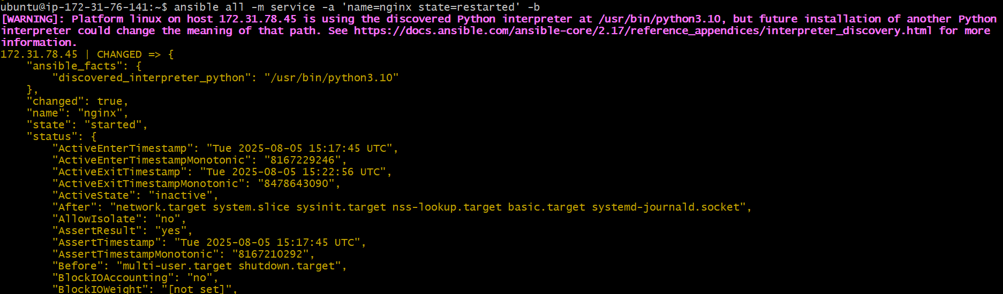

1. URI service:

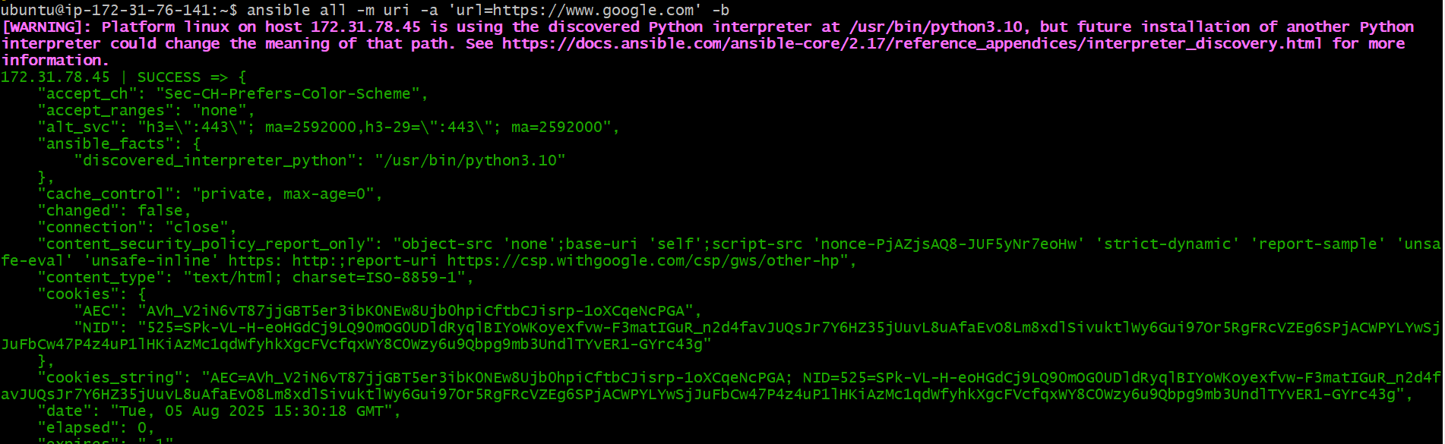

1. Basic playbook.yaml

---

* Name: My First Playbook

Hosts: all

Tasks:

- Name: Installation of Apache2

Apt:

Name: apache2

State: present

…

Ansible-playbook playbook.yaml -b

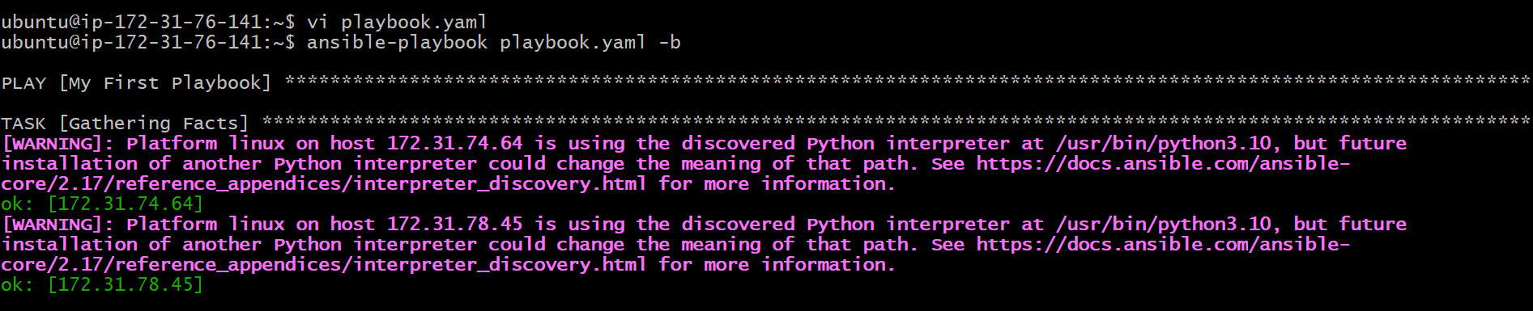

Worker-node-2:

Apache2 successfully installed

